 | Job Description
Position Title: | Head Gardener - Pukeiti
Responsible to: | Operations Manager Regional Gardens
Responsible for: | Gardeners at Pukeiti
Relationships: | Regional Gardens staff  All Taranaki Regional Council staff  General Public
Salary: | A market salary for the position will be negotiated, depending on experience, qualifications and aptitude.
Location: | Pukeiti Garden
Job Context: | Permanent Full Time

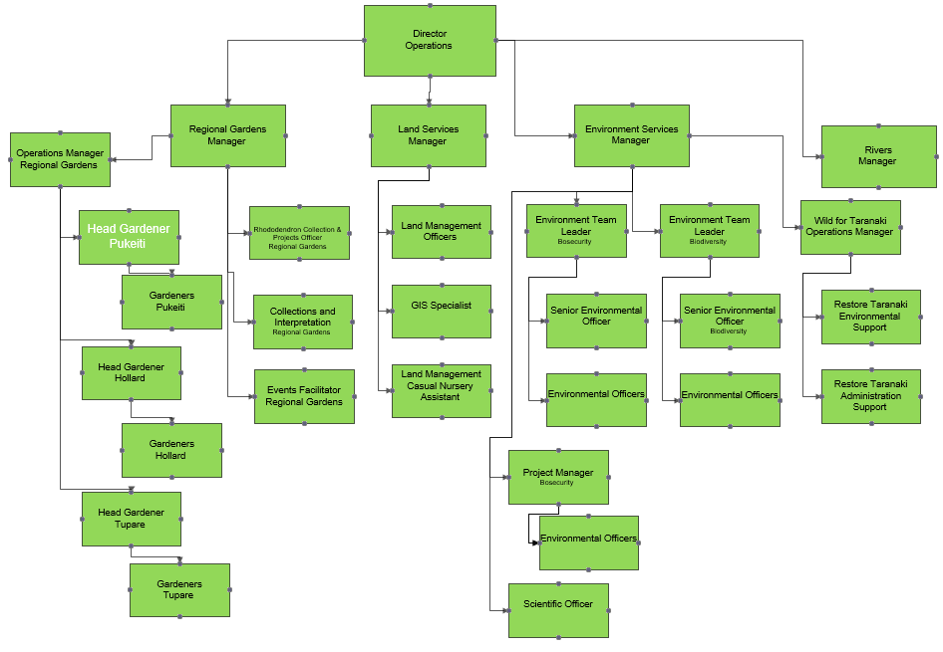

Role of a Head Gardener - Pukeiti
The role of a Head Gardener – Pukeiti is to provide hands on leadership, guidance and training to the Pukeiti gardening team.
The Head Gardener manages the day to day garden operations, contributing curatorial input into the maintenance and developments of the gardens and plant collection, and to assist in the promotion of Pukeiti.

Key Skills

Qualification
- Required: previous experience and relevant qualifications in amenity horticulture or public gardening

Knowledge
- Knowledge of garden management, trees and plants both native and exotic
- Computer literacy, including confidence in a range of Microsoft Office products

Skills / Experience
- Extensive experience in plant care
- Experience in team leadership
- Practical experience in garden maintenance and best practice
- Excellent communication skills
- Strong organisation and time management skills
- Problem solving skills
- Ability to operate and maintain a wide range of powered hand tools
- Drivers Licence for manual vehicles

Personal Attributes
- Natural leadership qualities
- Team player
- Practical problem solver
- Finely tuned attention to detail and time management
- Excellent initiative
- Good level of fitness (some heavy lifting will be required)
- Innovative and self-motivated

Tasks

- Present and maintain Pukeiti to the standard established in the Pukeiti asset management plan
- Lead, manage and develop the Pukeiti gardening team to maximise their potential and to assist in the delivery of Pukeiti to the standards established in the Pukeiti asset management plant
- Apply curatorial skills to the maintenance and enhancement of Pukeiti, the plant collection and the plant database
- Promote the increased public use of Pukeiti via events and functions
- Participate in a full range of gardening and curatorial activities
- Welcome and conduct visitors around the property and communicate to them the stories and history associated with Pukeiti
- Any other task and duties as required by the Operation Manager – Regional Gardens, Regional Gardens Manager, Director – Operations Manager or Chief Executive
Special requirements
- May be required to work outside normal working hours
- Must be able to undertake the physical requirements of the position
- May be required to work with hazardous and toxic materials
- May be expected to work under conditions in which personal risk is incurred, due to the nature of the position. Safety procedures must be adhered to in accordance with the Council’s Policies and Procedures.

Health and Safety
The Taranaki Regional Council is committed to a process of continuous improvement in order to achieve excellence in the management of health and safety at all of our workplaces. We recognise the positive impact that the values and benefits of enhanced health and safety bring to the organisation, our employees and our communities. There are two key points to health and safety:
- The safety of our people and the communities in which we operate always comes first.
- We are all empowered and expected to challenge any unsafe situation at work.

We will achieve these by:
- Building culture
- Aiming for zero harm
- Taking reasonable practicable steps
- Managing contractors
- Communicate
- Develop knowledge
- Investigate and learn
- Ensure competence to do the job

Mission and Key Message

Our Mission:
To work for a thriving and prosperous Taranaki by:
- Promoting the sustainable use, development and protections of our natural and physical resources
- Safeguarding Taranaki’s people and resources from natural and other hazards
- Promoting and providing for significant services, amenities and infrastructure
- Representing Taranaki’s interests and contributions to the regionally, nationally and internationally community

We will do this by leading with responsibility, working cooperatively, encouraging community participation, and taking into account the Treaty of Waitangi.

Our Key Message:
The Taranaki Regional Council works with the Taranaki community to help make our region a fantastic place to live, play and do business.

Values:
We are committed to:
- Public service
- Service First
- Improving the quality of our performance
- Working safely
- Effective communication and teamwork
- Initiative and the right to make mistakes
- Accountability and results
- Presentation, respect and care
- Job satisfaction

