 | Job Description
Position Title: | Policy Analyst
Responsible to: | Policy Manager
Responsible for: | N/A
Relationships: | Taranaki Regional Council Policy and Planning section  Other Taranaki Regional Council staff  Regional community, tangata whenua and local stakeholders  Other regional councils and territorial authorities
Salary: | A market salary for the position will be negotiated, depending on experience, qualifications and aptitude.
Holder: | Vacant
Location: | Based at the Regional Council premises in Stratford and may be required to travel throughout the Taranaki region as part of their daily duties.
Job Context: | Permanent, full-time

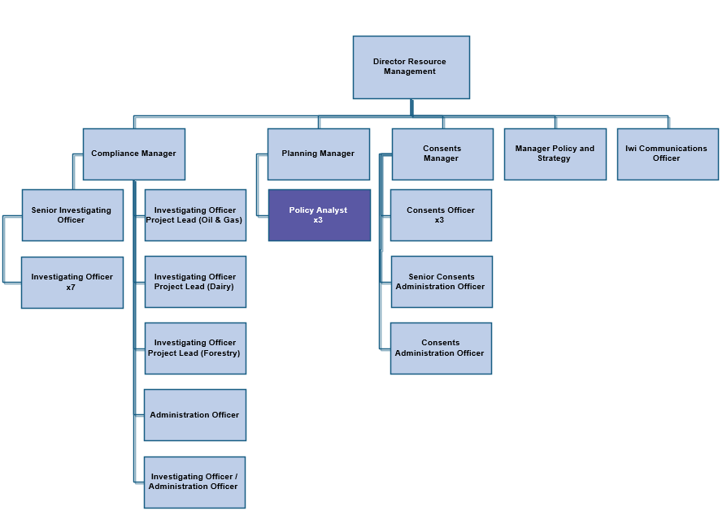

Role of Policy Analyst
- Analyse and review existing policies, regulations and legislation and develop proposals for new policy initiatives
- Assist in the preparation and review of regional resource management plans and other strategies or policy documents.
- Generally assess and develop resource management policy
- Provide policy advice on the Council's statutory responsibilities
Role Expectations
The expectations of this role are evident by:
- Strong analytical skills and an ability to translate complex policies, plans and legislation into succinct, understandable information.
- Strong time management skills including managing and prioritising work in a professional and timely manner.
- A commitment to getting the job completed efficiently, effectively and accurately.
- A positive and active involvement within the Policy and Planning team and the wider Resource Management team.
- Ability to develop and maintain positive relationships with the regional community, tangata whenua and local stakeholders.

Key Skills

Qualification
- Post-graduate qualification and experience in a similar position.

Knowledge
- Experience and training in policy analysis.
- An understanding of one or more of the science-based disciplines, for example, earth sciences, biological sciences, water chemistry or physical geography, and the ability to incorporate such knowledge into the policy and planning process.
- Ability to interpret monitoring data from a wide scientific information database and prepare relevant reports.
- Experience or good working knowledge of the Resource Management Act 1991 and the Biosecurity Act 1993.
- Appreciation of tikanga Māori.

Skills
- Excellent written and oral communication skills, including a proven report writing ability.
- Strong organisation and time management skills.

Personal Attributes
- A strategic approach.
- Methodical and common-sense approach to problem solving.
- Fluency in both written and spoken English.
- Ability to perform under pressure to meet tight timeframes.
- Excellent interpersonal skills.
- Ability to work with a wide range of other disciplines, particularly the sciences.
- High professional and ethical standards.
- Self-motivated, and objective driven.

Tasks

- Contribute to the development, investigation and/or review of existing regional council policies, plans, strategies or bylaws, including recommending appropriate modifications and changes.
- Provide other policy advice to assist the Council to carry out its statutory functions.
- Assess policies developed by other agencies and prepare submissions in response to those policies.
- Participate in committees, joint working parties or project teams as required.
- Provide expert evidence at hearings and other such forums as required.
- Respond to inquiries on the interpretation and application of regional council policy.
- Prepare, under the direction of the Policy Manager, reports or memoranda on other subjects as may be required from time to time.
- Perform such other tasks or duties as may be directed by the Policy Manager, Director—Resource Management, or the Chief Executive from time to time.

Health and Safety
The Taranaki Regional Council is committed to a process of continuous improvement in order to achieve excellence in the management of health and safety at all of our workplaces. We recognise the positive impact that the values and benefits of enhanced health and safety bring to the organisation, our employees and our communities. There are two key points to health and safety:
- The safety of our people and the communities in which we operate always comes first.
- We are all empowered and expected to challenge any unsafe situation at work.
We will achieve these by:
- Building culture.
- Aiming for zero harm.
- Taking reasonable practicable steps.
- Managing contractors.
- Communicate.
- Develop knowledge.
- Investigate and learn.
- Ensure competence to do the job.

Mission and Key Message

Our Mission:
To work for a thriving and prosperous Taranaki by:
- Promoting the sustainable use, development and protections of our natural and physical resources.
- Safeguarding Taranaki’s people and resources from natural and other hazards.
- Promoting and providing for significant services, amenities and infrastructure.
- Representing Taranaki’s interests and contributions to the regionally, nationally and internationally community.
We will do this by leading with responsibility, working cooperatively, encouraging community participation, and taking into account the Treaty of Waitangi.

Our Key Message:
The Taranaki Regional Council works with the Taranaki community to help make our region a fantastic place to live, play and do business.
Values:
We are committed to:
- Public service.
- Service First.
- Improving the quality of our performance.
- Working safely.
- Effective communication and teamwork.
- Initiative and the right to make mistakes.
- Accountability and results.
- Presentation, respect and care.
- Job satisfaction.

